Contents

1. Mutable and Immutable Data Types 2

# Mutable and Immutable Data Types

Immutable Data Types: Immutable data types are those whose values cannot be modified after they are created. If you try to change an immutable object, a new object is created instead of modifying the existing one.

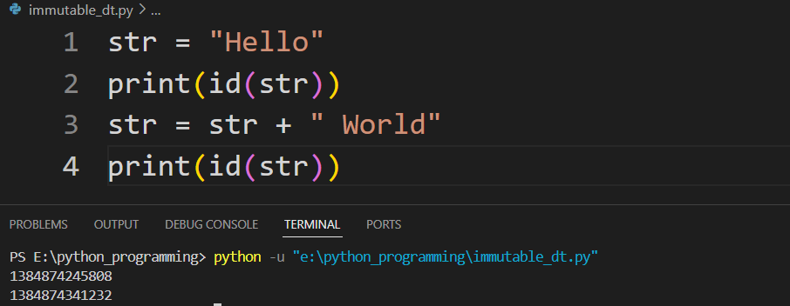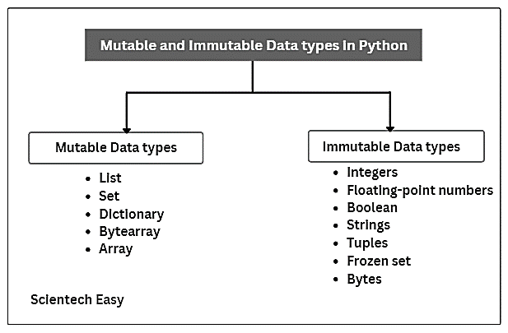Mutable Data Types: Mutable data types are those whose values can be changed after they are created.

In the given code, we start with a string str initialized to "Hello". When we print the id of str, it gives us the memory address where the string "Hello" is stored. Next, we modify str by concatenating it with " World", resulting in a new string "Hello World". When we print the id of str after this modification, it shows a different memory address. This demonstrates that strings in Python are immutable; modifying a string creates a new string object rather than changing the original one.